**Department of Information Technology**

**Academic Year: 2022-23 Name of Student:**

**Semester: VI Student ID:**

**Class / Branch / Div: TE- IT A/B Roll No.**

**Subject: MAD & PWA Lab Date of Submission:**

**Name of Instructor:**

**Experiment No.:3**

**Aim:** To design a layout of Flutter App using layout widgets.

**Prerequisites:** Android studio, flutter SDK **.**

**Problem Statement:** To develop a flutter UI for creating List View using Layout widgets of flutter.

**Software:** Android studio, flutter SDK **.**

**Code:**

import 'package:flutter/material.dart';

void main() => runApp(MyApp());

class MyApp extends StatelessWidget {

// It is the root widget of your application.

@override

Widget build(BuildContext context) {

return MaterialApp(

title: 'Flutter Demo Application',

theme: ThemeData(

primarySwatch: Colors.green,

),

home: MyHomePage(title: 'Complex layout example'),

);

}

}

class MyHomePage extends StatelessWidget {

MyHomePage({Key? key, required this.title}) : super(key: key);

final String title;

@override

Widget build(BuildContext context) {

return Scaffold(

appBar: AppBar(title: Text("Product List")),

body: ListView(

padding: const EdgeInsets.fromLTRB(3.0, 12.0, 3.0, 12.0),

children: <Widget>[

ProductBox(

name: "iPhone",

description: "iPhone is the top branded phone ever",

price: 55000,

image: "iphone.png"),

ProductBox(

name: "Android",

description: "Android is a very stylish phone",

price: 10000,

image: "android.png"),

ProductBox(

name: "Tablet",

description: "Tablet is a popular device for official meetings",

price: 25000,

image: "tablet.png"),

ProductBox(

name: "Laptop",

description: "Laptop is most famous electronic device",

price: 35000,

image: "laptop.png"),

ProductBox(

name: "Desktop",

description: "Desktop is most popular for regular use",

price: 10000,

image: "computer.png"),

],

));

}

}

class ProductBox extends StatelessWidget {

ProductBox(

{Key? key,

required this.name,

required this.description,

required this.price,

required this.image})

: super(key: key);

final String name;

final String description;

final int price;

final String image;

Widget build(BuildContext context) {

return Container(

padding: EdgeInsets.all(2),

height: 110,

child: Card(

child: Row(

mainAxisAlignment: MainAxisAlignment.spaceEvenly,

children: <Widget>[

Image.asset("assets/" + image),

Expanded(

child: Container(

padding: EdgeInsets.all(5),

child: Column(

mainAxisAlignment: MainAxisAlignment.spaceEvenly,

children: <Widget>[

Text(this.name,

style: TextStyle(fontWeight: FontWeight.bold)),

Text(this.description),

Text("Price: " + this.price.toString()),

],

)))

])));

}

}

**Output:**

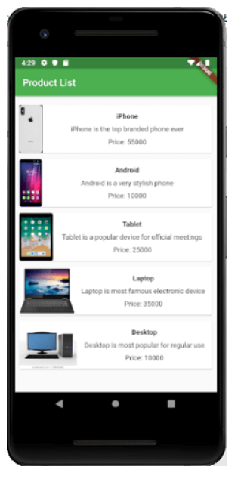

**Conclusion:** In this experiment we have designed a layout by using flutter various layout widgets.